Functional & Technical Specification: tsi compose

A CLI tool to pick, configure, and launch the exact modules your stack needs.

Executive Summary
tsi compose is the CLI-driven orchestration engine and developer experience (DX) primitive for the TSI Coop ecosystem. Designed specifically for in-house engineering teams and Independent Software Vendors (ISVs), tsi compose enables developers to declaratively select, configure, and provision modular, headless DPDP-compliance backend microservices directly into their local environments or deployment pipelines.
By treating DPDP compliance as composable data infrastructure, tsi compose allows organisations to adopt only the backend primitives they need—such as consent management (tsi-dpdp-cms), PII isolation (tsi-privacy-vault), eSign gateways (tsi-sign), peer-to-peer exchange (tsi-dx-node), and compliance logging (tsi-compass)—without replacing their existing API gateways, IAM systems, or middleware stacks.

Functional Specification

1. Target Audience & Positioning
- Primary Users: Lead Architects, DevOps Engineers, Backend Software Developers, and ISV Product Teams.
- Positioning: Headless, developer-first, open-source infrastructure launcher.
- Core Value Proposition: Zero-friction scaffolding that turns complex DPDP compliance modules into a single-command docker-compose setup.

2. Functional Workflow & User Journey
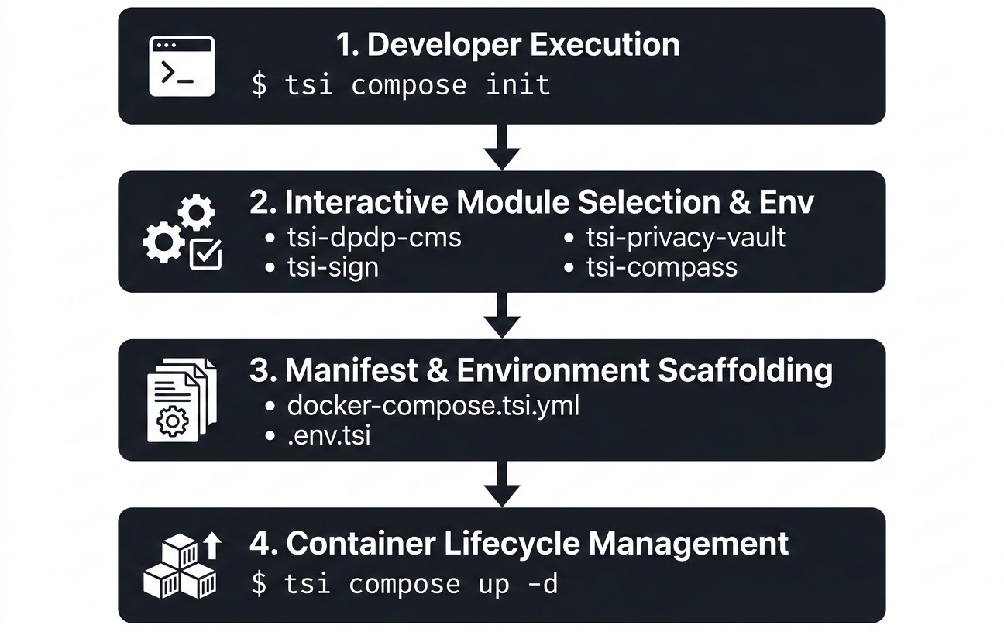

A. Interactive Stack Initialization (tsi compose init)
- Prompts the developer to interactively select required TSI backend modules.
- Solicits database preference (spin up a localized PostgreSQL container or link to an existing enterprise database).
- Automatically resolves inter-service dependencies (e.g., auto-selecting tsi-dpdp-cms if tsi-privacy-vault requires consent gating).
- Scaffolds two deterministic files in the current working directory:
  - docker-compose.tsi.yml: Production-ready Compose manifest.
  - .env.tsi: Environment configuration template populated with secure defaults.

B. Lifecycle & Runtime Operations
- Launch: tsi compose up launches containers in background or attached mode.
- Status Check: tsi compose status reports real-time container health, API port bindings, and endpoint readiness.
- Unified Observability: tsi compose logs streams aggregated, color-coded stdout/stderr logs across all active TSI microservices.
- Teardown & Cleanup: tsi compose down cleanly stops containers and manages optional volume persistence flags.

Technical Specification

1. Architecture & Binary Design
tsi compose is built as a core subcommand group within the Go-based tsi-cli binary (tsi). It leverages native Go libraries and interacts with local runtime engines via standard Docker API sockets and the Open Compose Specification (compose-spec.io).

Plaintext
tsi-cli (Go Binary)
├── cmd/
│ └── compose/
│ ├── init.go # Interactive wizard & template renderer
│ ├── up.go # Docker Compose executor wrapper
│ ├── status.go # Healthcheck & API status inspector
│ └── logs.go # Log multiplexer & streamer
├── pkg/
│ ├── templates/ # Embedded Go templates (.tmpl) for Compose manifests
│ └── docker/ # Docker SDK / Socket client wrappers

2. Embedded Service Catalog
Module | Core Functionality | Primary Ports | Default Dependencies
tsi-dpdp-cms | Headless Consent State Machine | 8081/tcp | PostgreSQL
tsi-privacy-vault | PII Isolation & Tokenization Engine | 8082/tcp | PostgreSQL, Redis
tsi-sign | eSign 2.1 / eMudhra Gateway API Wrapper | 8083/tcp | None (Stateless)
tsi-dx-node | Peer-to-Peer mTLS Data Exchange Node | 8084/tcp | mTLS Certificates
tsi-compass | IT GRC & Evidence System of Record | 8085/tcp | PostgreSQL

3. CLI Command Matrix

Bash
# Initialize a new composable stack definition interactively
tsi compose init [--config <path>] [--non-interactive]
# Bring up the provisioned stack
tsi compose up [-d|--detach] [--build]
# Stop and remove stack containers and networks
tsi compose down [--volumes]
# Display running container status, port mappings, and health
tsi compose status
# Stream aggregated logs across active TSI modules
tsi compose logs [-f|--follow] [--tail <lines>]

4. Sample Generated Manifest (docker-compose.tsi.yml)

YAML
version: '3.8'
services:
tsi-dpdp-cms:
image: ghcr.io/tsicoop/tsi-dpdp-cms:latest
container_name: tsi-dpdp-cms
ports:
- "${CMS_PORT:-8081}:8081"
env_file:
- .env.tsi
healthcheck:
test: ["CMD", "curl", "-f", "http://localhost:8081/health"]
interval: 10s
timeout: 5s
retries: 3
restart: unless-stopped
tsi-privacy-vault:
image: ghcr.io/tsicoop/tsi-privacy-vault:latest
container_name: tsi-privacy-vault
ports:
- "${VAULT_PORT:-8082}:8082"
env_file:
- .env.tsi
depends_on:
tsi-dpdp-cms:
condition: service_healthy
restart: unless-stopped
tsi-sign:
image: ghcr.io/tsicoop/tsi-sign:latest
container_name: tsi-sign
ports:
- "${SIGN_PORT:-8083}:8083"
environment:
- EMUDHRA_STORE_TO_DB=false
- ESIGN_VERSION=2.1
env_file:
- .env.tsi
restart: unless-stopped
networks:
default:
name: tsi-mesh-network

Security, Compliance & Governance
- Non-Invasive Architecture: tsi compose provisions purely stateless or isolated backend microservices. It does not inspect, proxy, or intercept host traffic outside the defined container networks.
- Data Sovereignty & Ephemerality: All environment variables, crypto keys, and secret configurations are maintained in .env.tsi locally on the host machine. Secrets are never transmitted back to any external telemetry servers.
- Stateless Operations: Third-party gateway modules (such as tsi-sign) are pre-configured to strictly enforce transient payload processing (StoreToDB=false), preventing persistent document storage outside the organisation's control boundary.

Distribution & Build Pipeline
- Distribution Channels:
  - Homebrew: brew install tsicoop/tap/tsi
  - Go Install: go install [github.com/tsicoop/tsi-cli/cmd/tsi@latest](https://github.com/tsicoop/tsi-cli/cmd/tsi@latest)
  - Standalone Binaries: Cross-compiled GitHub Releases for Linux (amd64/arm64), macOS (darwin/arm64), and Windows (amd64).
- Licensing: Apache 2.0 / MPL 2.0 (Open-Source).

